**1. Introduction:**

E-commerce has revolutionized the way businesses operate and how consumers shop. With the increasing prevalence of online shopping, there is a growing demand for efficient and user-friendly e-commerce platforms. This project aims to address this need by developing an online e-commerce website software that provides a seamless shopping experience for users.

**2. Background Study:**

The rise of e-commerce has been fueled by advancements in technology and changes in consumer behavior. Traditional brick-and-mortar stores are increasingly moving their operations online to reach a wider audience and capitalize on the growing trend of online shopping. As such, there is a pressing need for robust and reliable e-commerce solutions that can cater to the diverse needs of businesses and consumers alike.

**3. Objectives:**

* Develop a comprehensive e-commerce website software with essential features such as product catalog, shopping cart, user authentication, and payment gateway integration.
* Create an intuitive and user-friendly interface to enhance the shopping experience for users.
* Ensure the security and privacy of user data through robust authentication and encryption mechanisms.
* Implement efficient inventory management and order processing functionalities to streamline business operations.

**4. Features:**

* Product catalog with detailed product listings and descriptions.
* Shopping cart functionality for users to add and manage items before checkout.
* User authentication and registration system to secure user accounts and personal information.
* Payment gateway integration to facilitate secure online transactions.
* Order management system for administrators to track and process orders efficiently.

**5. Requirements:**

**Functional Requirements:**

* Product catalog: Display products with images, descriptions, and prices.
* Shopping cart: Allow users to add, remove, and update items in their cart.
* User authentication: Secure login and registration process for users.
* Payment gateway integration: Support for various payment methods such as credit/debit cards, digital wallets, and net banking.
* Order management: Enable administrators to view, process, and fulfill orders.

**Non-functional Requirements:**

* Performance: Ensure fast loading times and responsiveness.
* Scalability: Ability to handle a large number of concurrent users and products.
* Security: Implement measures to protect user data and prevent unauthorized access.
* Usability: Intuitive user interface with easy navigation and accessibility features.
* Compatibility: Support for different web browsers and devices.

**6. Contribution:**

This project contributes to the field of e-commerce by providing a robust and user-friendly online shopping platform that meets the needs of both businesses and consumers. It demonstrates the application of software development methodologies and technologies to address real-world challenges in the e-commerce domain.

**7. Methodology:**

* Requirement Analysis: Identify and document functional and non-functional requirements through stakeholder interviews and market research.
* System Design: Design the system architecture, database schema, user interface, and backend functionalities using industry best practices.
* Implementation: Develop the e-commerce website software using technologies such as HTML, CSS, JavaScript, PHP, Laravel, and MySQL.
* Testing: Conduct thorough testing, including unit testing, integration testing, and user acceptance testing, to ensure the quality and reliability of the software.
* Deployment: Deploy the e-commerce website software on a web server and make it accessible to users.

**8. SRS:**

**9. Design diagram:**

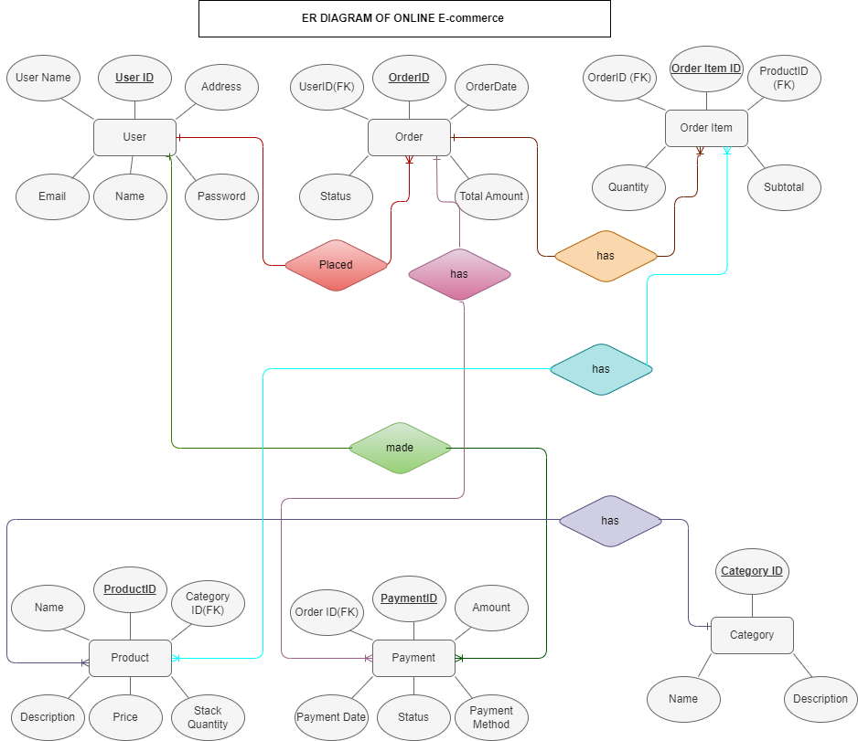

**Figure 01: ER Diagram**

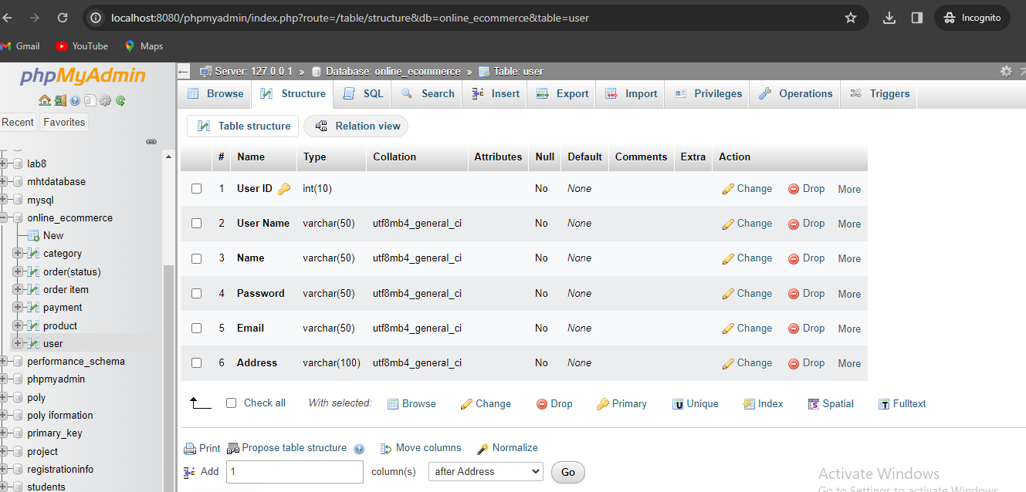

**Figure 02: Database**

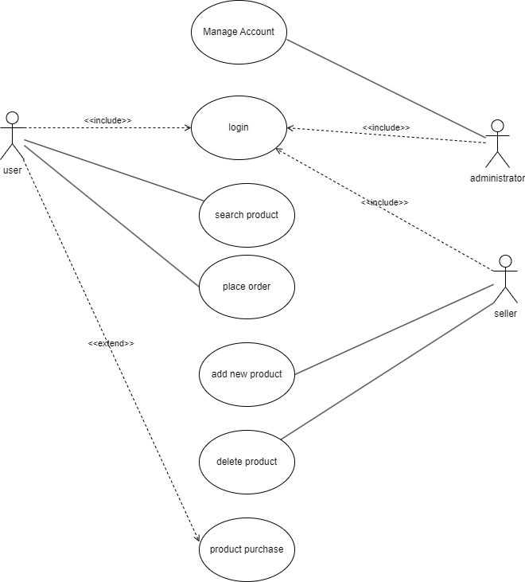

**Figure 03: use case diagram**

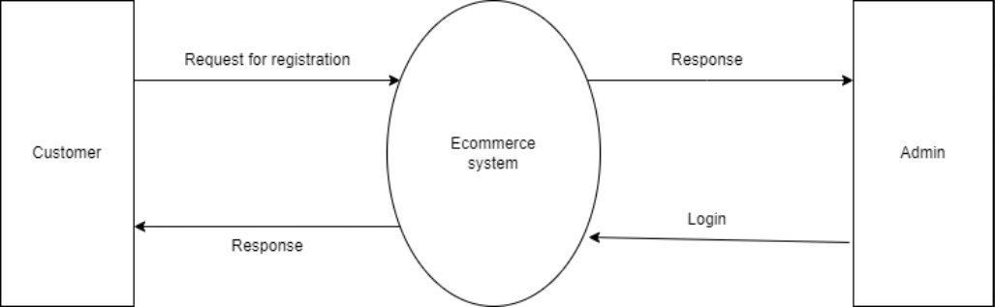

**Figure 04: DFD 0**

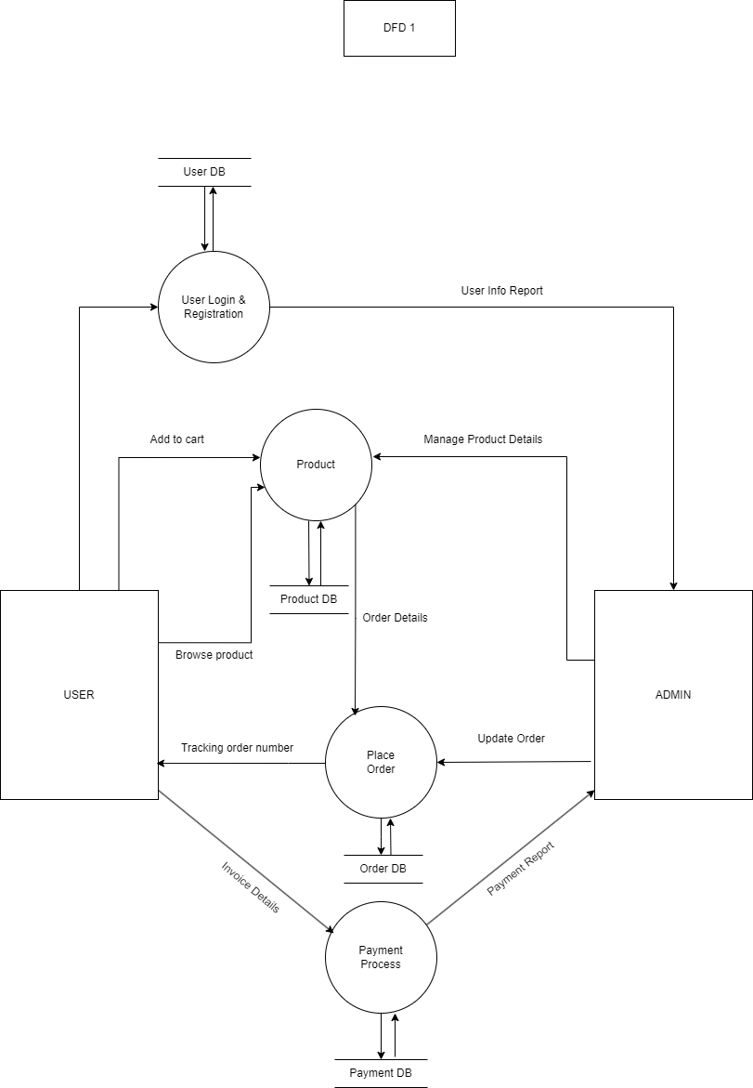

**Figure 05: DFD 1**

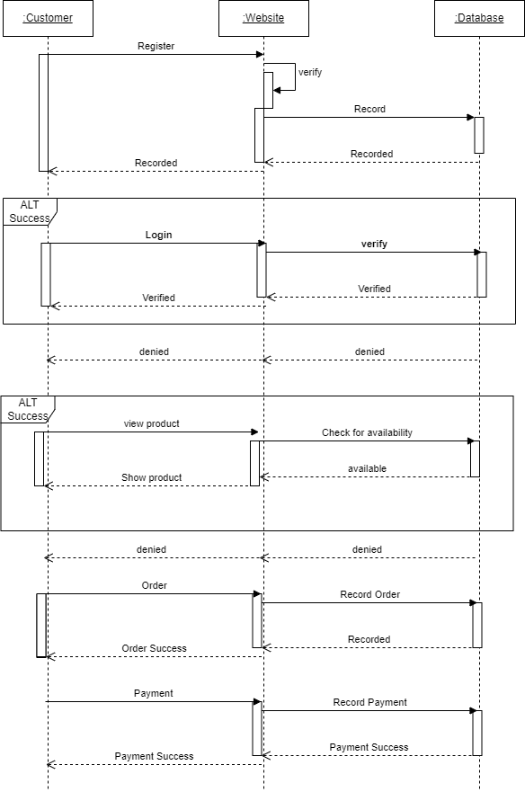

Figure 06: sequence diagram

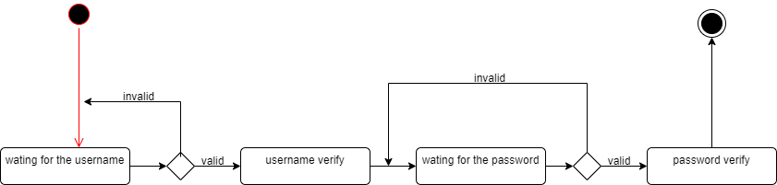

**Figure 07: State diagram 1**

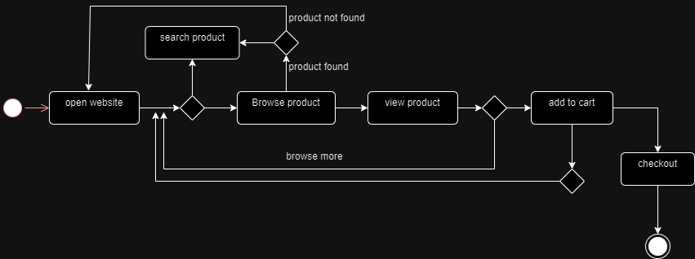

**Figure 08: State diagram 2**

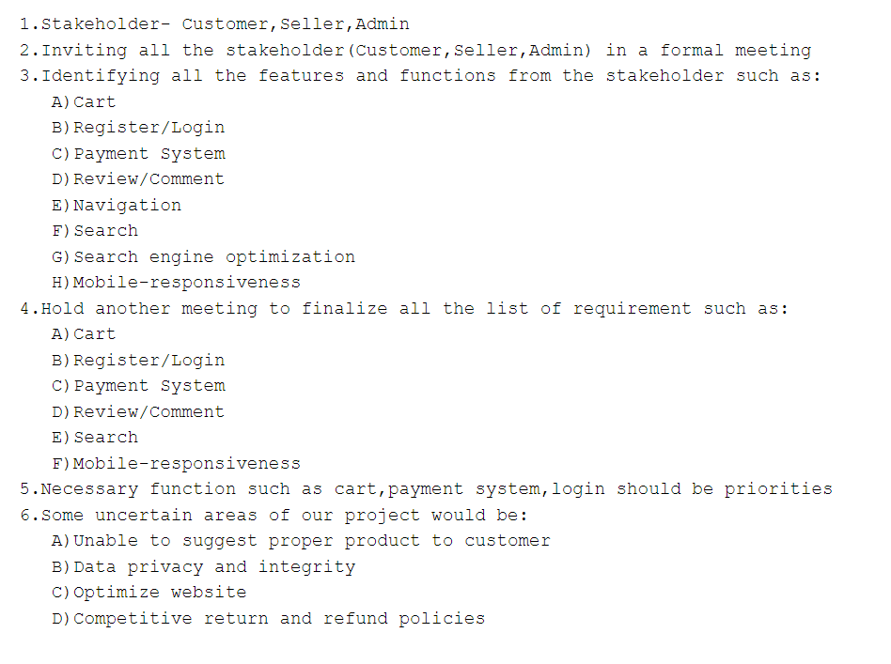

**Figure 09: Task set**

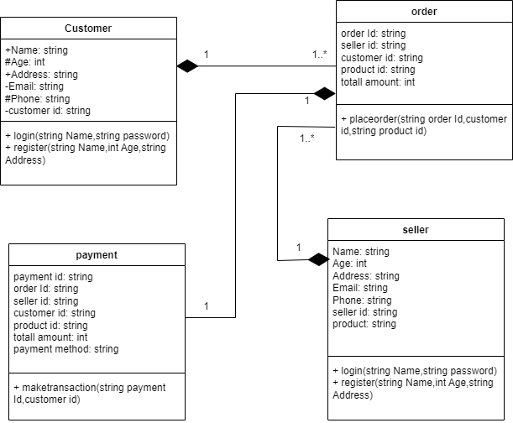

**Figure 10: UML Class diagram**

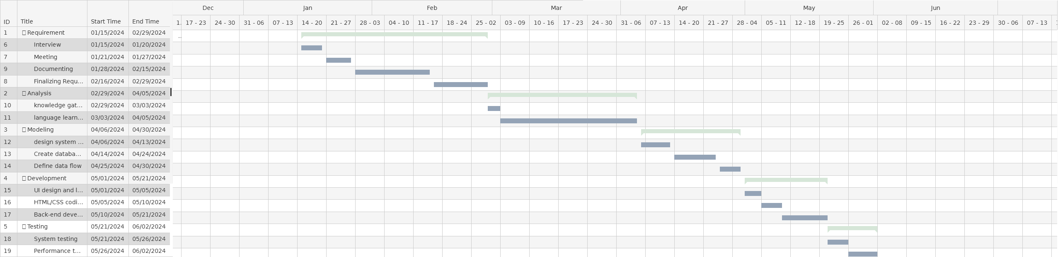

**Figure 11: Gantt Chart**

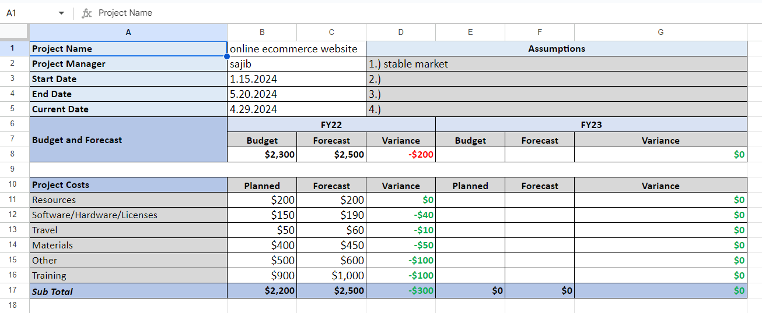

**Figure 12: Budget**

**9. Implementation:**

* Front-end Technologies: HTML, CSS, JavaScript for building the user interface.
* Back-end Technologies: PHP for implementing business logic and server-side functionality.
* Database Management: MySQL for storing product information, user data, and transaction records.
* Development Tools: Integrated development environments (IDEs) such as Visual Studio Code, Sublime Text, and database management systems (DBMS) like phpMyAdmin.

**10. Testing Report:**

**11. Future Work:**

* Integration with third-party services such as social media platforms and analytics tools.
* Enhancements to the user interface for better usability and accessibility.
* Implementation of advanced features such as recommendation engines and personalization algorithms.
* Continuous monitoring and optimization of performance and security aspects.

**12. Limitations:**

* Limited resources and time constraints may have impacted the scope and depth of the project.
* The software may require further refinement and optimization to address scalability and performance issues under heavy loads.
* Compatibility issues with certain web browsers or devices may arise, requiring additional testing and debugging.

**13. Conclusion:**

The development of the online e-commerce website software has successfully achieved its objectives of providing a robust, user-friendly, and secure platform for online shopping. The software has the potential to significantly enhance the e-commerce experience for both businesses and consumers, contributing to the growth and success of the online retail industry.

**14. References:**

1. Smith, J. (2023). E-Commerce Essentials: Building Successful Online Businesses. Wiley.
2. How To Create A Free Website - with Free Domain & Hosting complete guidline for begener, <https://www.youtube.com/results?search_query=how+to+create+a+website>
3. E-Commerce Trends 2023. (n.d.). Retrieved May 13, 2024, from https://www.ecommercetrends.com